Ideation Phase
Define problem Statement
Date | November 2, 2025
Team ID | F53C03230D9D3649CD4402B24FF15FEB
project Name | Educational organization using ServiceNow

Project: Educational Management System Using ServiceNow
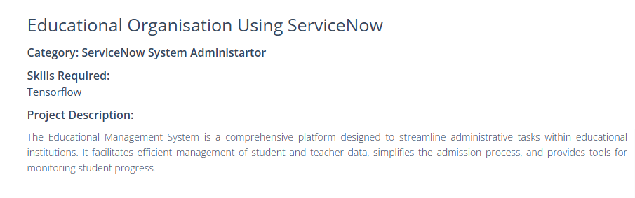
1. Who is the user?
The primary users are School Administrators and Admissions Officers in a growing educational institution.

2. What is the problem?
The current process for managing new student admissions and tracking academic progress is manual, decentralized, and inefficient. Staff rely on paper forms and disconnected spreadsheets, which leads to significant time spent on data entry, a high risk of data errors, and no clear visibility into a student's status (e.g., "Is this admission approved?") or performance (e.g., "What is this student's average grade?").
3. Why does it matter?
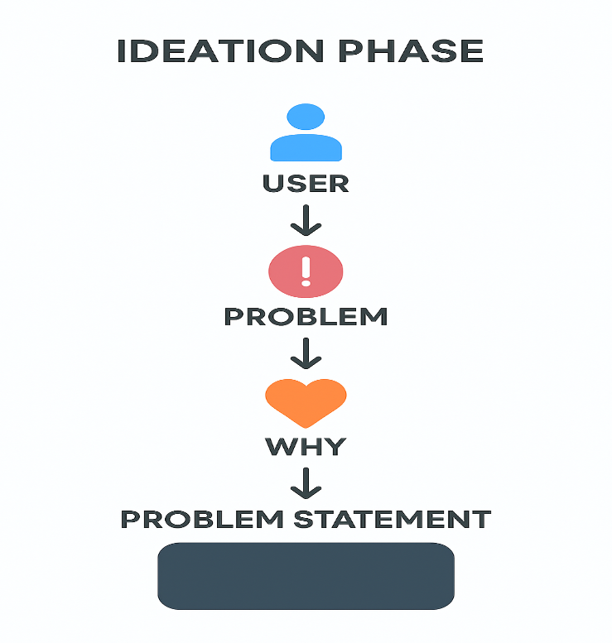
This inefficiency wastes valuable administrative time that could be spent on student-focused activities. Data errors can lead to incorrect student records and flawed progress reports, negatively impacting both the students and the institution's reputation.
Problem Statement:
"School administrators need a unified and automated system to manage the complete student lifecycle, from admission to progress tracking. The current manual methods are inefficient, error-prone, and prevent staff from having a single, reliable source of truth for student data, ultimately hindering their ability to support students effectively."

